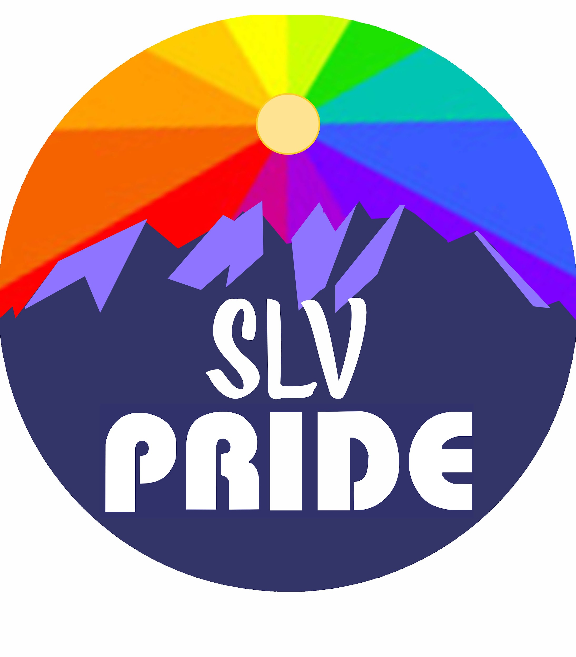
Dear Vendor:

Welcome to the San Luis Valley PrideFest! Thank you for your interest in joining this exciting event.

This year’s SLV PrideFest will be from 11 a.m. to 4 p.m. on Saturday, August 24, 2024 in Cole Park in Alamosa. Vendor check-in and set-up will be from 8 a.m. to 10 a.m. on Saturday morning.

VENDOR DETAILS

- Pricing:
Non-profit informational booth: $45.00 (Early bird price $35.00)
Vendor/Activity booth: $65.00 (Early Bird price $55.00)

- The vendor application deadline is August 1, 2024. Booth payment must be included with the application. Early Bird vendors receive a discount on the booth cost, and their deadline is June 15, 2024.

- Checks can be made out to: SLV Pride.

- All booth spaces are 12’ x 12’. You must provide your own booth, table, chairs, and all set-up materials.

- There is very limited availability for food vendors. Food vendors must provide a menu with pricing included in the application.

- Vendors will be informed whether or not they have been accepted through email within one month.

- Vendor applications that are not accepted will have booth fees returned.

- Applications can be mailed to PO Box 1948 Alamosa, CO 81101

Frequently asked questions

What if I need electricity?
There are outlets in the park, let us know if you will need electricity. Voltage goes up to 240v. Electricity will be provided on a first-come, first-serve basis, as availability permits.

Do I need insurance?
Booths must provide proof of insurance and business license, if applicable.

What if I want multiple spaces?
We are open to vendors wishing to have more space, just contact the Vendor Chair for more information.

What if I’m selling food?
Food vendors must provide license and health food inspection certification with permit. For any questions, contact the Alamosa County Health Department at 719-589-4848.

What about sales tax?
Vendors will be responsible to collect city sales tax, and to collect and report any other vendor taxes. Sales tax forms will be included in the vendor registration packet which is handed out upon check-in. City Sales tax forms can be mailed to the City of Alamosa: PO Box 419, Alamosa, CO 81101. For any questions, please contact the City of Alamosa at 719-589-2593.

When it’s done?
Vendors are required to stay for the entire time, and will be responsible for all their own cleanup and trash pickup. Trash receptacles will be available throughout the event.

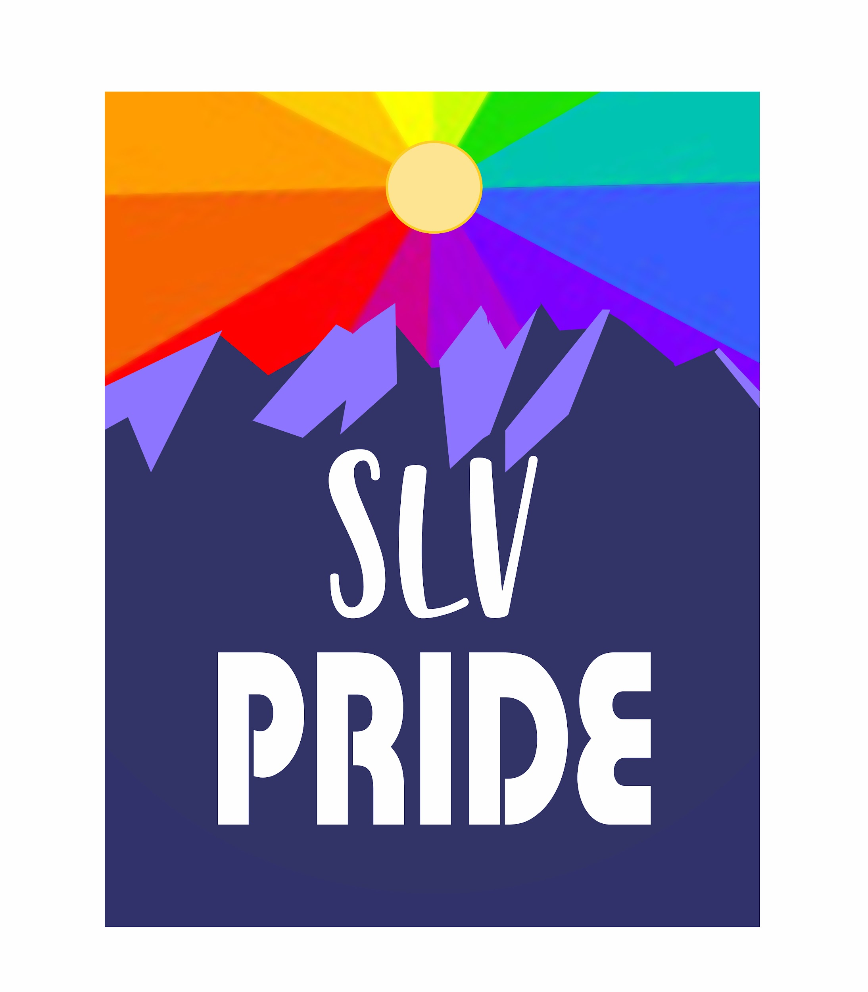

SLV PRIDEFEST VENDOR APPLICATION FORM

Organization / Business Name_____________________________________________
Contact Name__________________________________________________________
Phone Number___________________ Email ________________________________
Address: ______________________________________________________________
City______________________ State_________ Zip Code ______________
Type of booth: information/non-profit____ vendor_____ food____ activity____
Detailed description of booth, information to be displayed, merchandise being sold, including prices: _________________________________________________________________________________________________________________________________________________________________________________________________________________________________________________________________________________________________________________________________________________________________________________________________________________________________________________________________________________________________________________________________________________________________________
Disclaimers: This will be a rain-or-shine event, please be prepared for all types of weather, including rain and wind. Please be courteous of Cole Park and others around you. We reserve the right to decline applications deemed unsuitable due to type of activity, electricity needs, proposed prices, or redundancy of booth type.
This is a family-friendly, inclusive event. We reserve the right to deny service and/or ask vendors to leave the day of the event for reasons including but not limited to: inappropriate/dangerous/hateful behavior or misrepresentation of booth. In such cases, booth fees will not be refunded.
By signing this form I have read, understand, and agree to abide by the provisions of the festival.
PRINT NAME:________________________________________________
SIGNATURE: _____________________________ DATE_____________
If you have any questions, please contact Vendor Chair sanluisvalleypride@gmail.com.
****************************************************************************************************
Committee use only

Date Received_________ Approved- Yes / No Date confirmation sent____________

Confirmation method_____N/A_________ Payment & Method ___Free of Charge________
Notes__Vendor will be providing services to the public. ____________________________________________________________________________________________________________________________________________

